Test Log musicOnline.com

Test Date: 11/03/2026
Project: musicOnline Website Project
By: Justyna Kucwaj

Test Strategy
This project was tested manually using the website interface in a browser.
The tests were carried out from the user perspective to check whether each page and feature works correctly.
A black box testing approach was used, so the focus was on inputs, outputs and expected behaviour rather than the internal code.
Both successful actions and invalid cases were tested.
Screenshots were taken as evidence for each test result.
If a problem was found, the code was corrected and the feature was retested.

Test No | Action | Expected | Actual | Result (pass/fail)
HOME
1 | Home page loads correctly | Home page opens successfully and displays all main sections correctly, including the header, navigation bar, hero section, latest vinyl listings and footer. |  | pass
2 | Search bar on home page works | When a valid keyword is entered (for example band- Metallica), the system returns matching vinyl listings or redirects the user to the catalogue/search results page with relevant results shown | A search was performed using the title of an existing vinyl listing, however no results were returned.  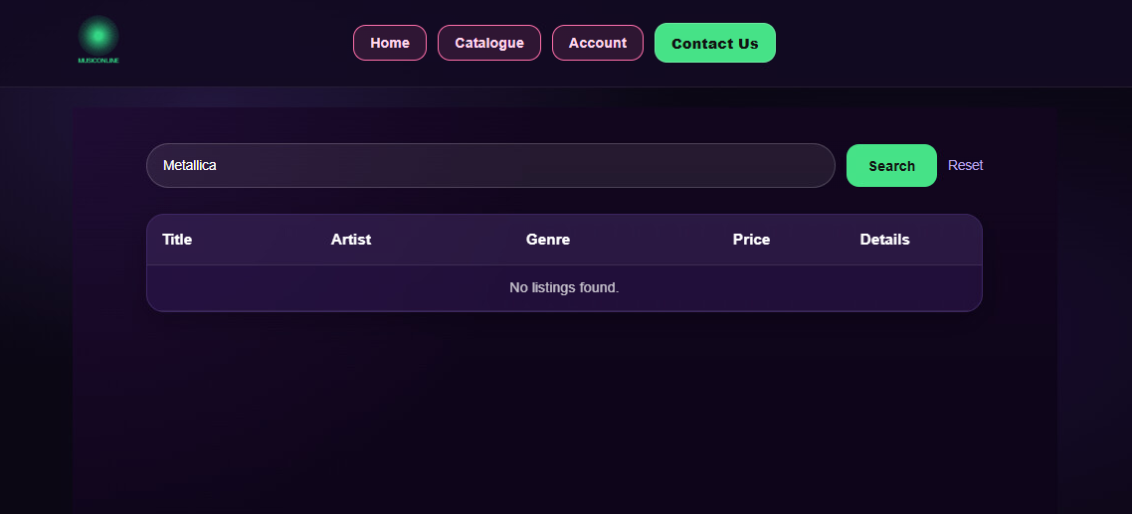 | Fail
3 | Latest vinyl listings are displayed | The home page displays four latest vinyl listings retrieved from the database. |  | pass
4 | Clicking a latest listing opens correct details page | When the user clicks on one of the latest vinyl listings, the system opens the correct details page for that selected vinyl. | 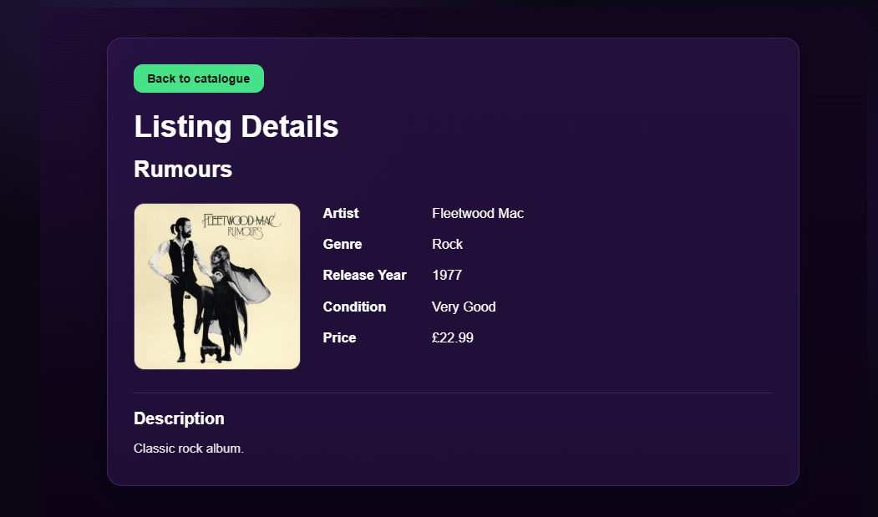 | pass
CATALOGUE / DETAILS
5 | Catalogue page loads correctly | The catalogue page opens successfully and displays the page layout correctly, including the header, search bar, vinyl listings and footer. | 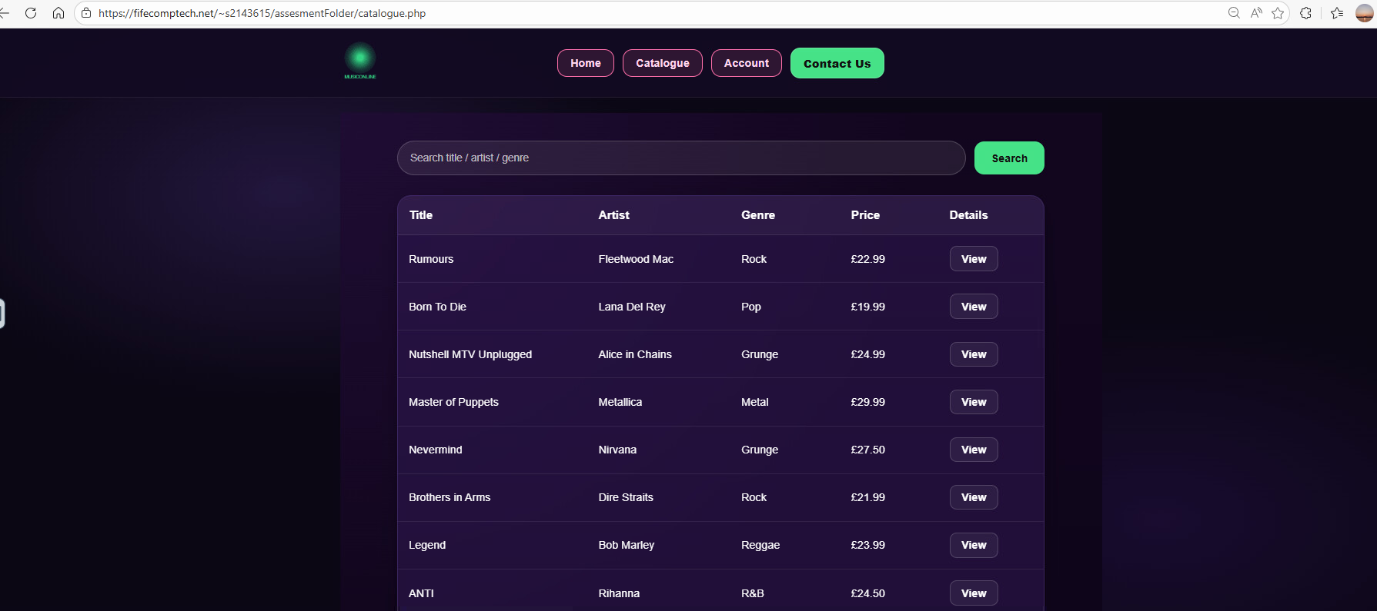 | pass
6 | Catalogue displays all available listings | All available vinyl listings stored in the database are displayed on the catalogue page with the correct basic information. |  | pass
7 | Search bar filters catalogue results | When a valid keyword is entered, the catalogue displays only the listings that match the search term. | 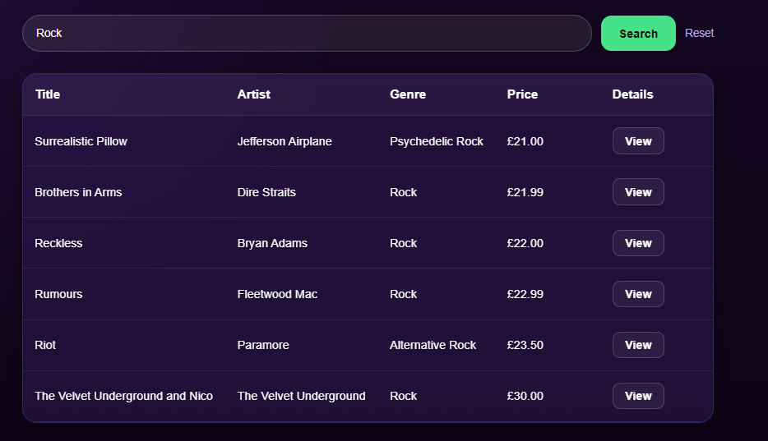 | pass
8 | View Details button opens selected listing | When the user clicks the View Details button, the system opens the correct details page for the selected vinyl listing. |  | pass
9 | Back to Catalogue button works from details page | When the Back to Catalogue button is clicked on the details page, the user is returned to the catalogue page successfully. |    | pass
ACCOUNT
10 | Valid user login works | When valid user credentials are entered, the system authenticates the user successfully and redirects them to the user panel. (for example casual user) | 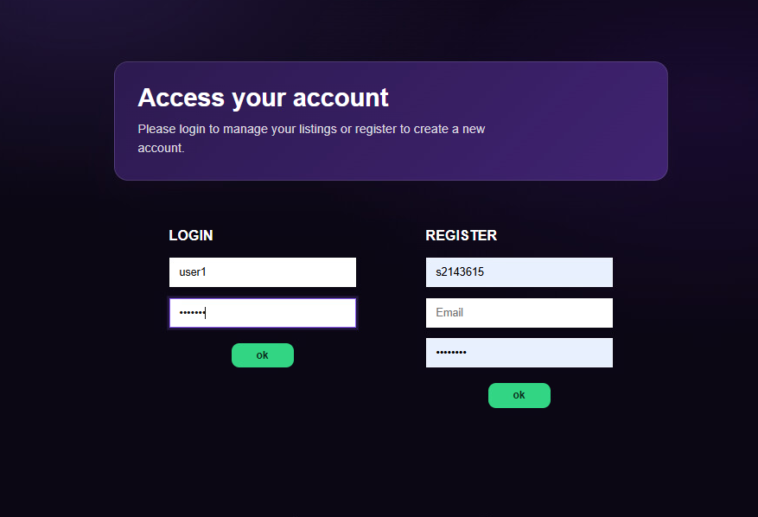  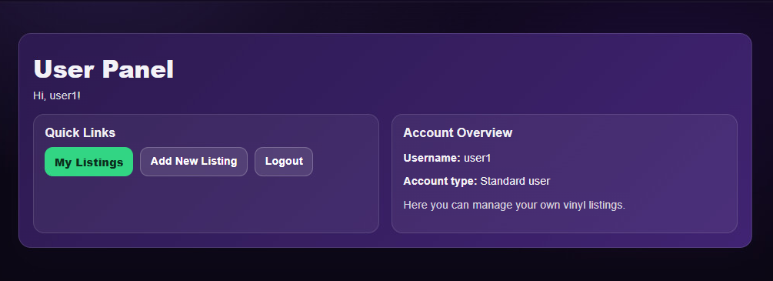 | pass
11 | Invalid login shows error message | When incorrect login credentials are entered, the system denies access and displays an error message informing the user that the login details are invalid. | 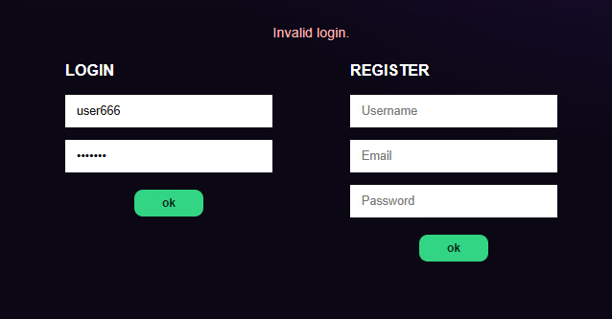 | pass
12 | Valid registration creates new account | When the user completes the registration form with valid information and submits it, a new user account is successfully created and stored in the database. | 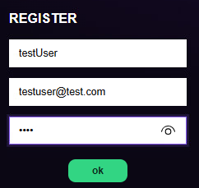 | pass
13 | Registration with missing fields is rejected | If the user submits the registration form with missing required fields, the system prevents submission and displays an appropriate validation message.  Screenshot: | 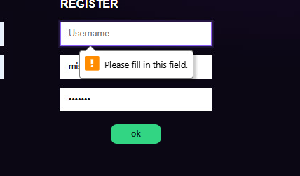 | pass
USER PANEL
14 | User panel opens after user login | After a successful user login, the system redirects the user to the user panel and displays the available user options correctly. | 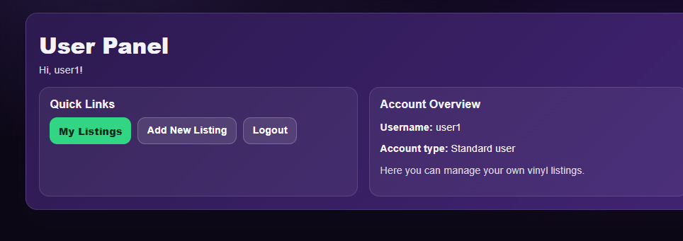 | pass
15 | My Listings section displays user’s listings | The My Listings section displays all vinyl listings created by the logged-in user with the correct information. | 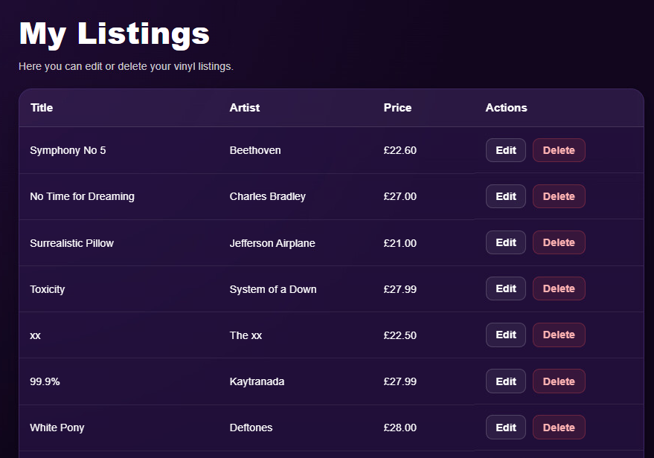 | pass
16 | Add New Listing works | When the user completes the add listing form with valid information and submits it, the new listing is successfully added and displayed in the user’s listings. | 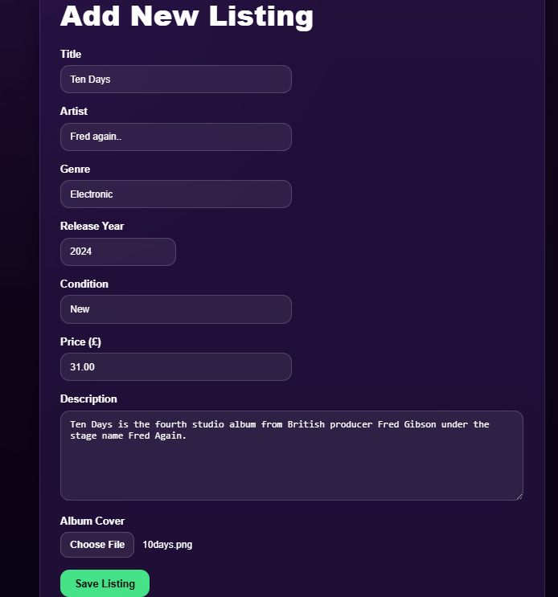    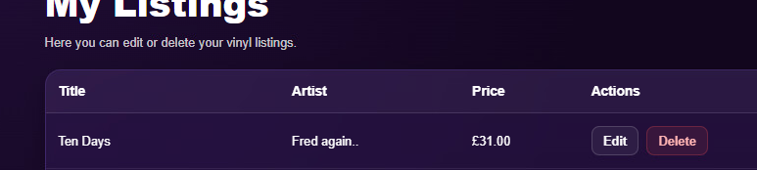 | pass
17 | Edit own listing works | When the user edits one of their own listings and saves the changes, the updated listing information is displayed correctly.  In that case, user want to change price from31.00 to 37.59. | The edit form opened and changes weren’t submitted and price value was not reflected in the listing.  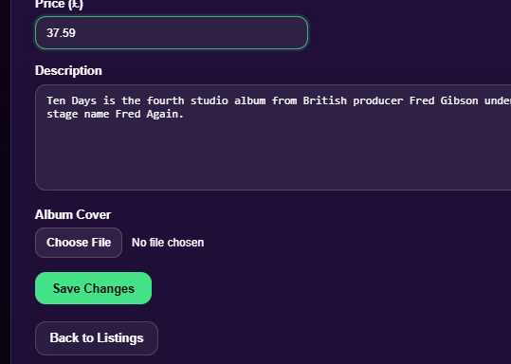  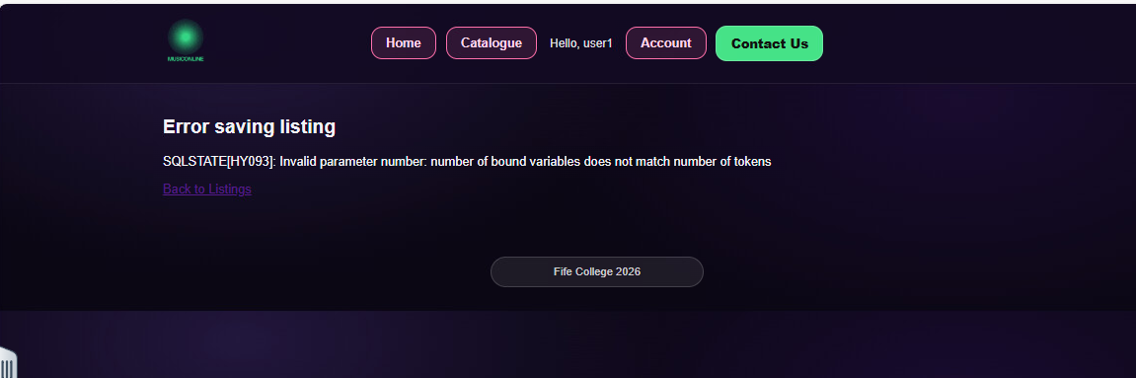 | fail
18 | Delete own listing works | When the user deletes one of their own listings, the selected listing is removed from the user’s listings and no longer appears in the system. | 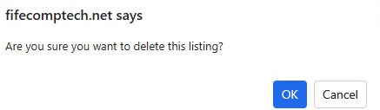  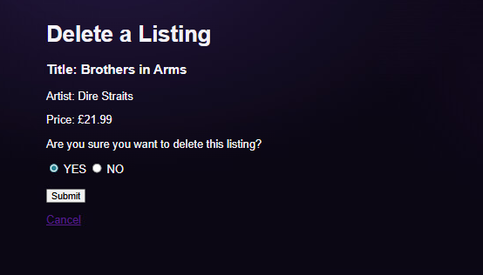   | pass
19 | Logout works | When the user clicks the logout button, the session is ended and the user is redirected to the appropriate, home page. |  | pass
ADMIN PANEL
20 | Admin panel opens after admin login | After a successful admin login, the system redirects the admin to the admin panel and displays the available admin options correctly. | 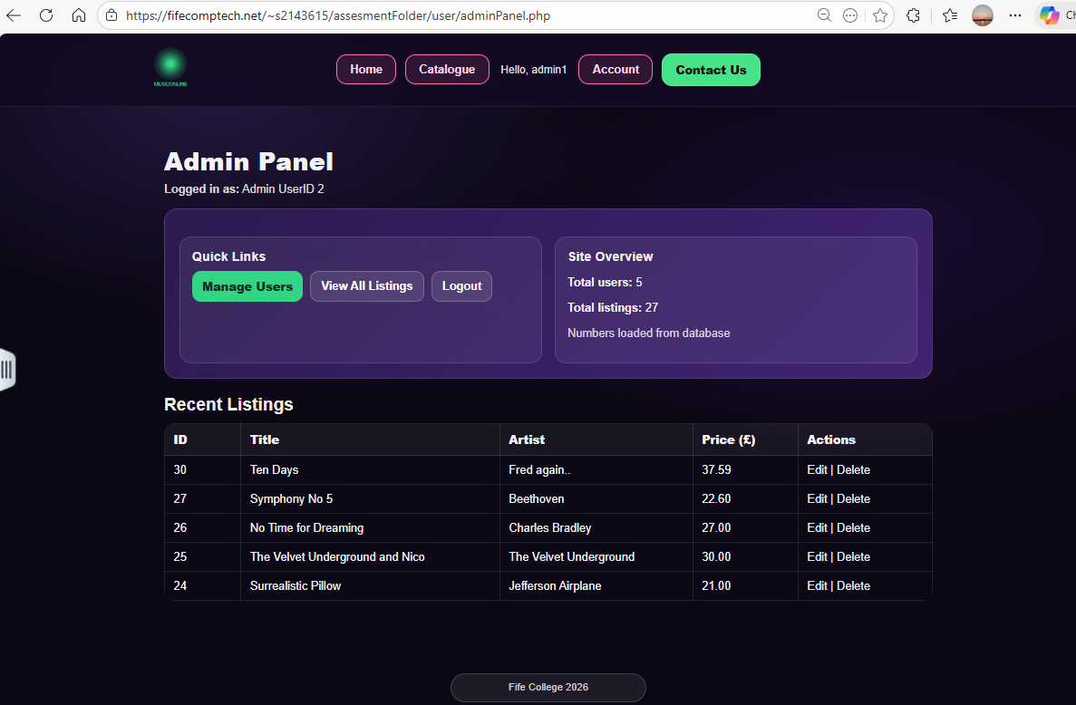 | pass
21 | Manage Users page displays users | The Manage Users page opens successfully and displays all registered users with the correct information. | 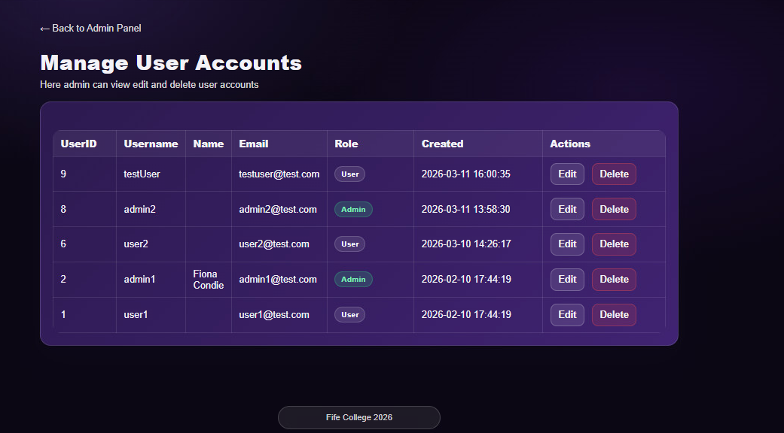 | pass
22 | Admin can edit a user | When the admin edits a selected user and saves the changes, the updated user information is stored and displayed correctly. | When the admin opened the edit user page, the system displayed a PHP parse error instead of loading the form correctly.  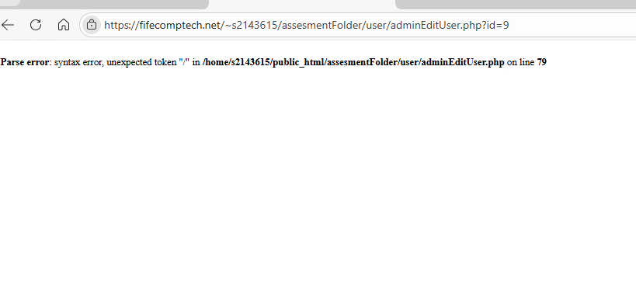 | fail
23 | Admin can delete a user | When the admin deletes a selected user, that user is removed from the system and no longer appears in the users list. | 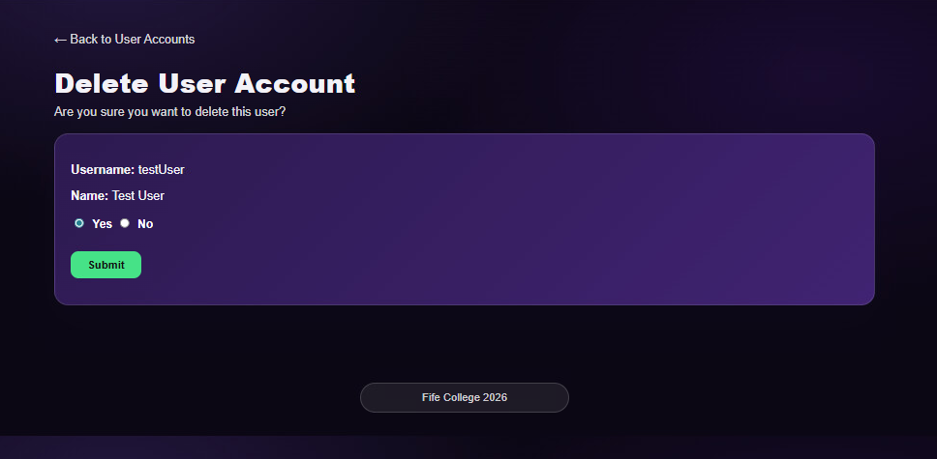   | pass
24 | View All Listings displays all listings | The View All Listings page opens successfully and displays all vinyl listings stored in the system with the correct information. | 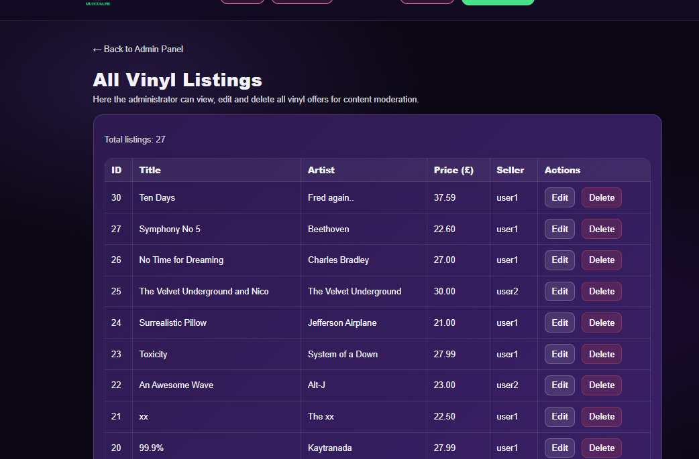 | pass
25 | Admin can edit any listing | In that case – condition Very Good to Good  When the admin attempted to save changes to a listing, the system displayed an SQL parameter error instead of updating the record. | 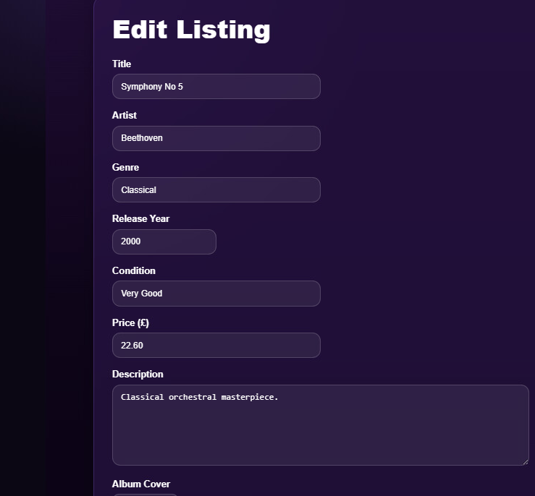  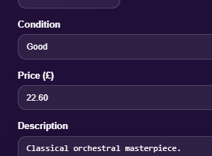  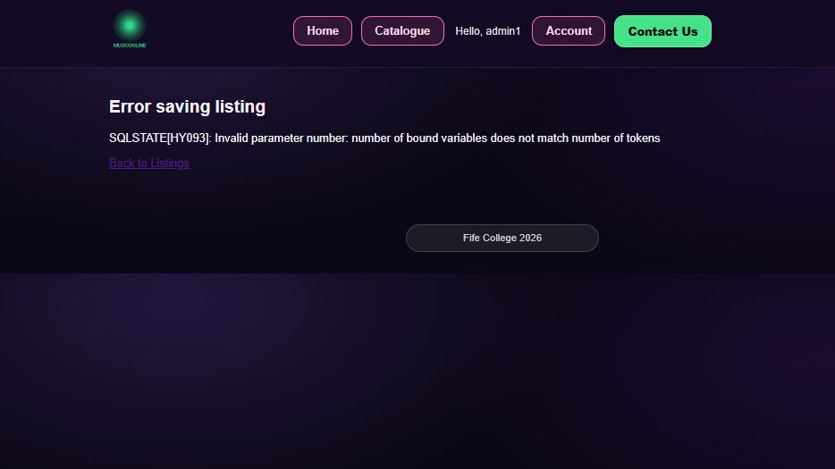 | fail
26 | Admin can delete any listing | When the admin deletes a selected listing, it is removed from the system and no longer appears in the listings list. | 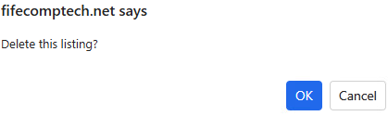  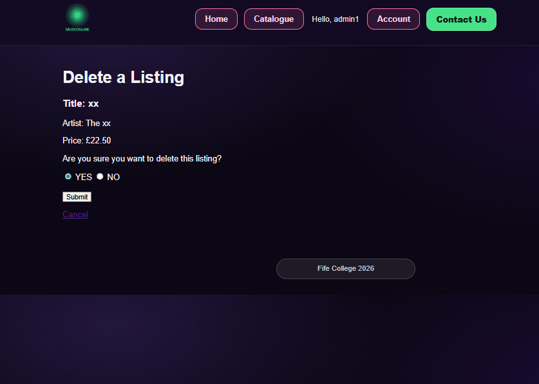 output: Invalid | Fail
CONTACT US
27 | Contact page loads correctly | The Contact Us page opens successfully and displays the contact form correctly, including all required input fields and the submit button. | 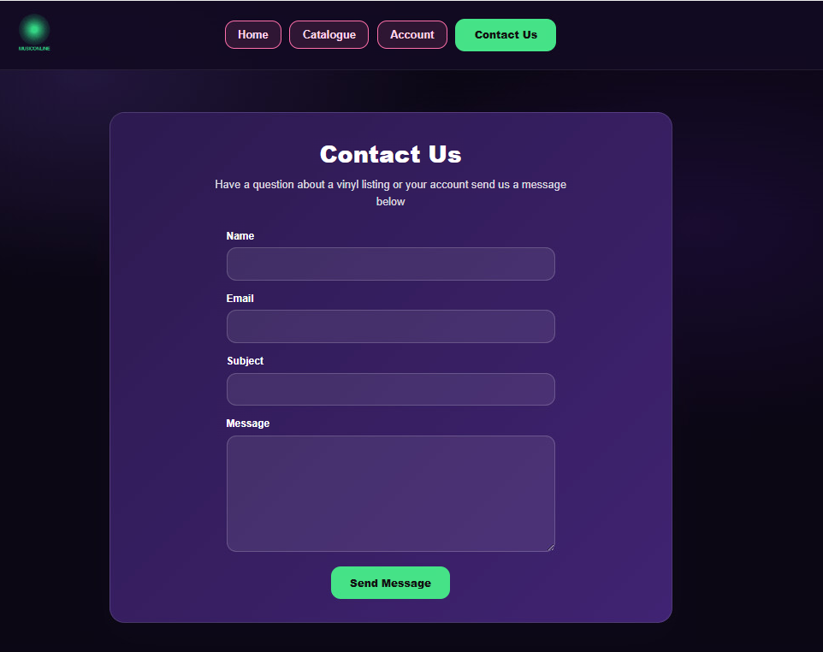 | pass
28 | Contact form submits with valid data | When the user completes the contact form with valid information and submits it, the form is accepted successfully, and a confirmation message is displayed. | 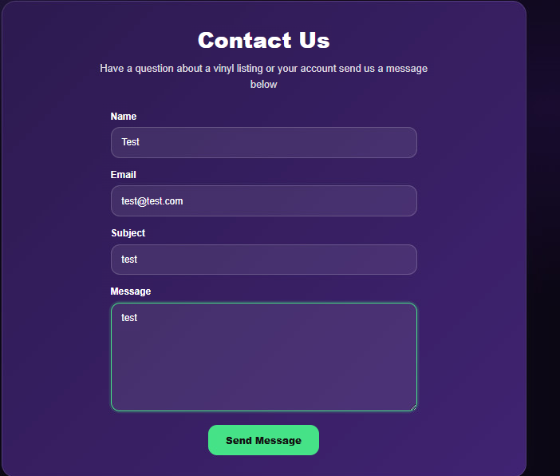  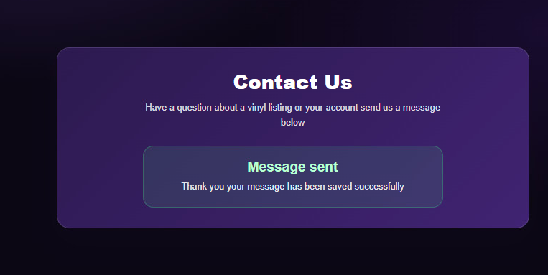 | pass
29 | Submitted contact form is stored in database | After a valid contact form submission, the submitted message is stored correctly in the database. | 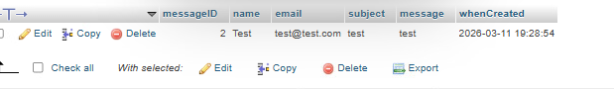 | pass
30 | Empty contact form is rejected | If the user submits the contact form with empty required fields, the system prevents submission and displays appropriate validation messages. | 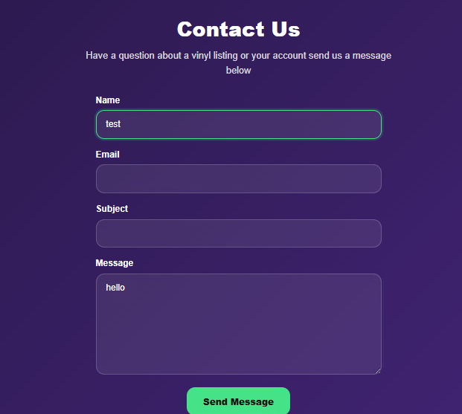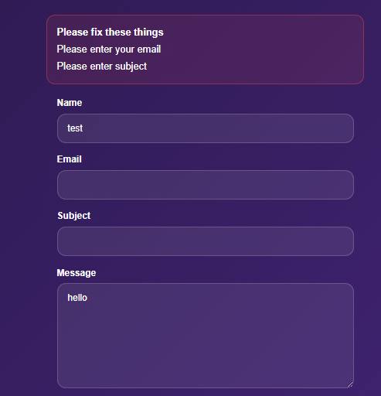 | pass
Test remediation - Retest
2 | Search bar on home page works after fix | Search returns matching vinyl listings. | 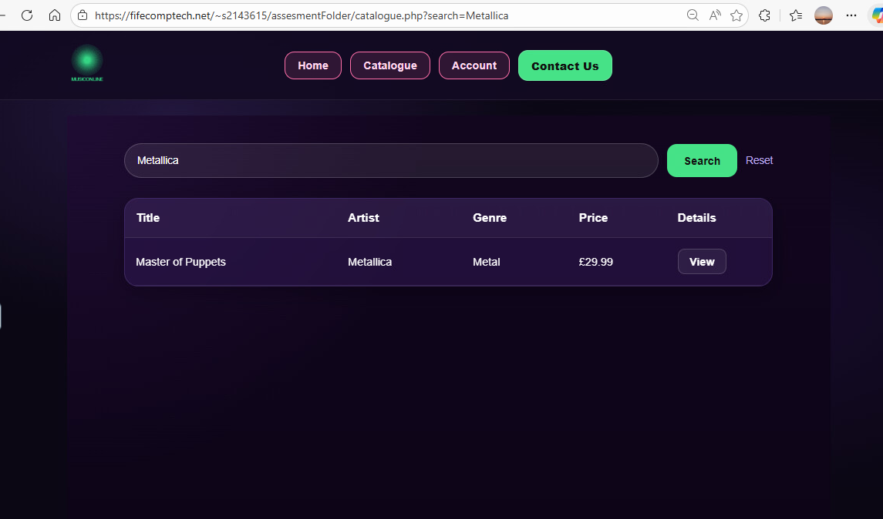 | Pass
17 | The issue was caused by the price field not being included in the update query. The query was corrected to include the price column so that the edited value is saved properly. | Price changed. |      | pass
22 | The issue was caused by a syntax error in the adminEditUser.php file. | User details edited | 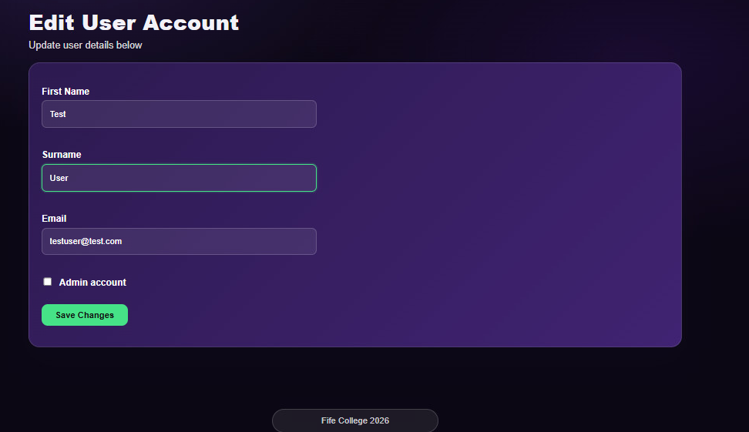  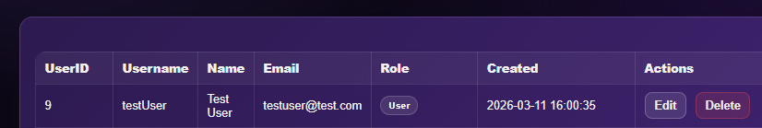 | pass
25 | The issue was caused by a mismatch between the SQL query placeholders and the bound parameters used during execution. The update statement and execute parameters were corrected so that all values matched properly. | When the admin edits a selected listing and saves the changes, the updated listing information is stored and displayed correctly. |  | pass
26 / added | Admin can delete listing from recent listings after fix. Click Delete in the Recent Listings section on the Admin Panel. | The selected listing is deleted successfully without invalid ID error. |  | Pass
31 - Login and search input handling tested after security remediation | Test login form and search form after applying input cleaning / sanitising changes. | User input is accepted and processed correctly, with forms working normally after security updates. | Login worked correctly with valid credentials, invalid login still showed an error, and search returned matching results correctly after the input handling fix. | pass

